|  |
| --- |
| SOFTWARE REQUIREMENTS SPECIFICATION SAMPLE DOCUMENT |
| OrangeHRM – My Info Module Qualifications – new feature |
| Project Functional Requirement Specification , Version 3.2 |
|  |
|  |
|  |

**This is a sample SRS document for the live project training on http://softwaretestinghelp.com. Please read this document and use it as a reference for our live software testing project.**

**12 Februarie 2022**

## My info Module

My Info Module is a powerful tool providing employees of the company with the ability to view relevant information such as personal information and updating personal information with an internet enabled PC without having to involve the HR department.

The functionality of this module spans through the entire system, making information available anywhere, anytime. All information is subject to the company's defined security policy, where he/she can only view the information he/she is authorized to. An ESS-User can only edit certain fields in the ESS Module, maintaining the security and confidentiality of employee information.

### Qualifications

The following options are available under the Qualifications section:

● Work Experience

Your previous work experiences can be entered here. To enter previous work experiences, click “Add” under “Work Experience” and the screen as shown in Figure 2.3 will appear.

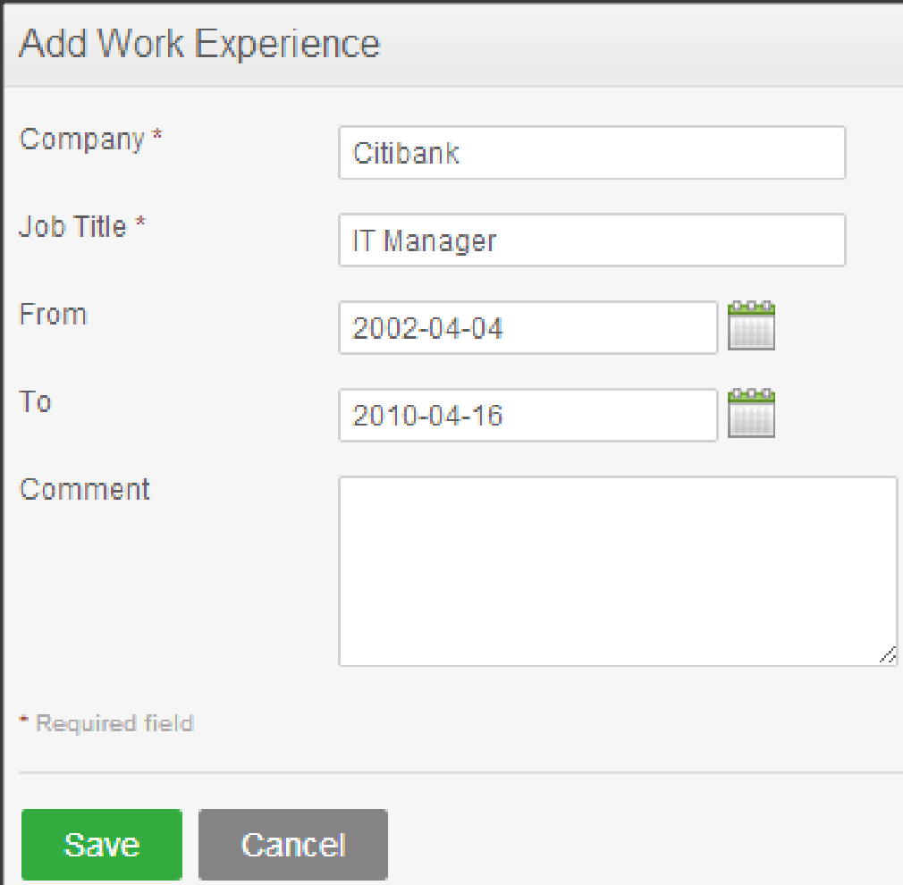

Click “Save” once all the fields are entered and the particular work experience will be listed as shown in Figure 2.4.

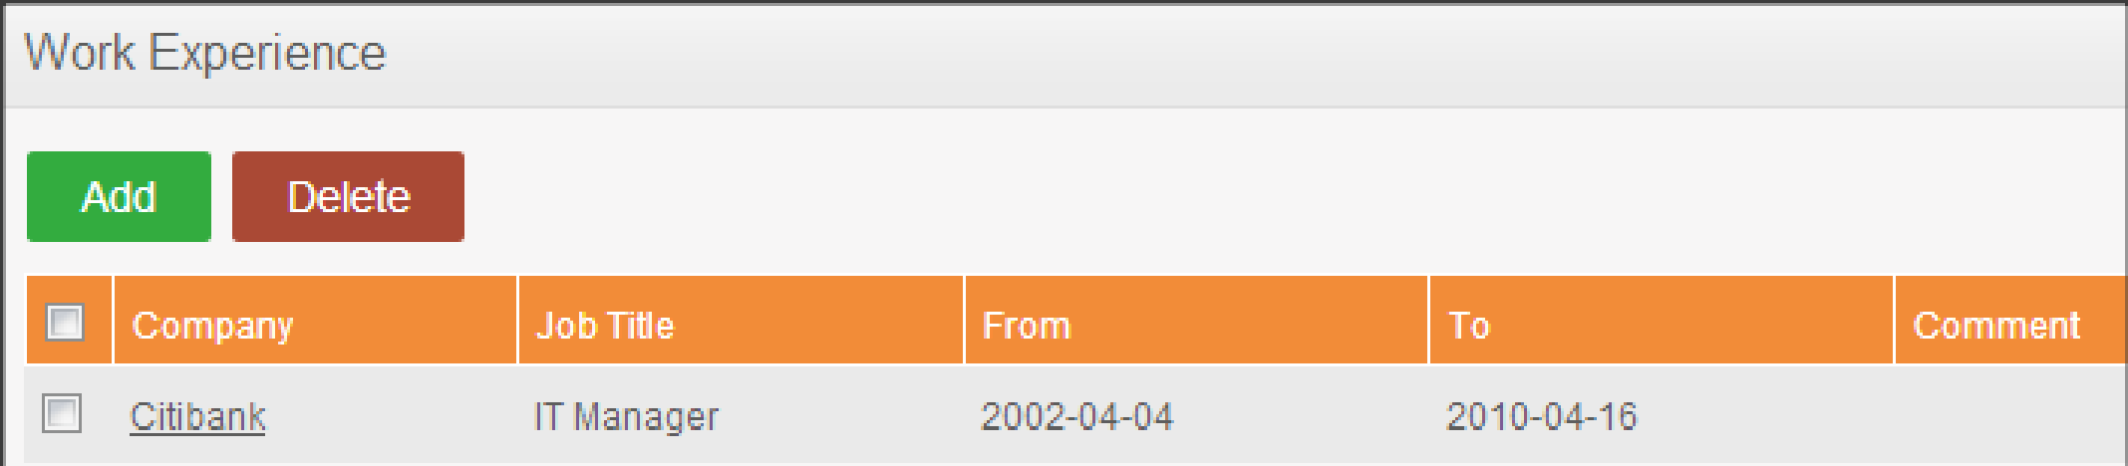

You may enter multiple entries of work experience.w

To delete an entry, click on the check box next to a particular entry. It is also possible to delete multiple entries at the same time by clicking the check box entries you wish to delete and simply clicking “Delete”.

● Education

You are able to enter details of your education here. To enter education details, click “Add” under “Education” and the screen as shown in Figure 2.5 will appear.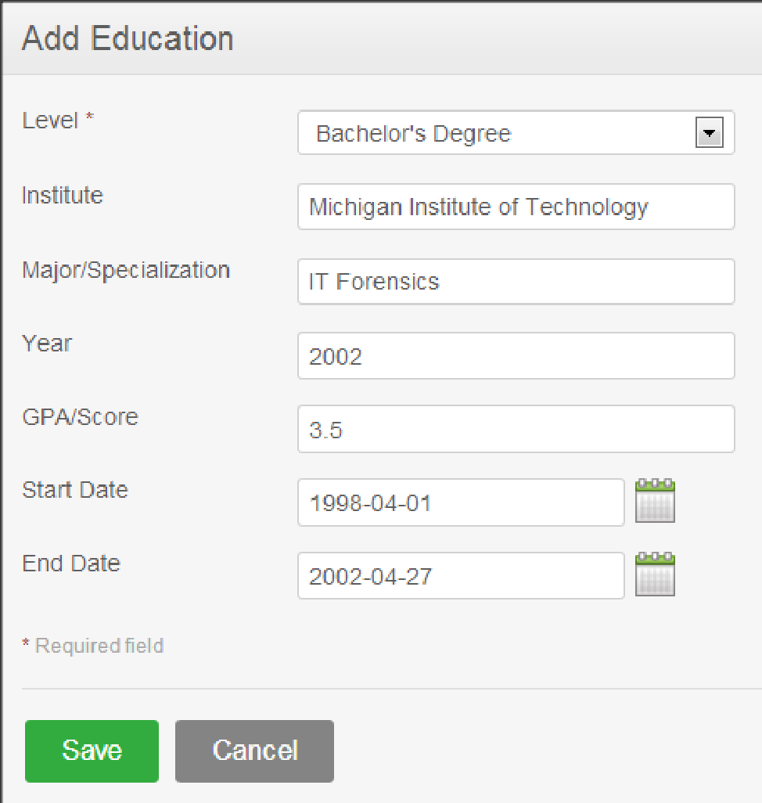

Click “Save” once all the fields are entered and the particular education details will be listed as shown in Figure 2.6. 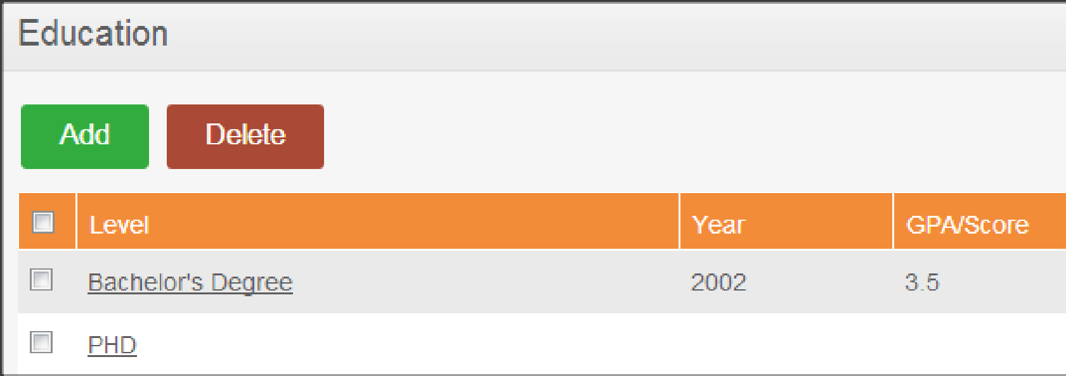

You may enter multiple entries of education.

To delete an entry, click on the check box next to particular entry. It is also possible to delete multiple entries at the same time by clicking the check box entries you wish to delete and simply clicking “Delete”.

● Skills

If you have any special talents or skills they can be entered here. To enter skills, click “Add” under “Skills” and the screen as shown in Figure 2.7 will appear.

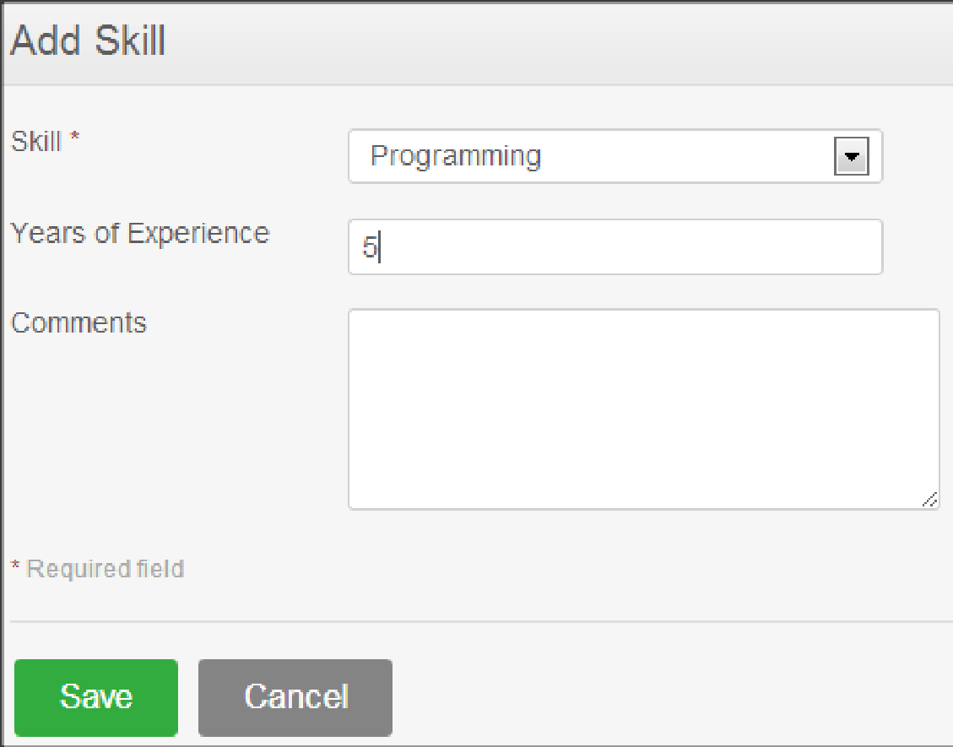

Click “Save” once all the fields are entered and the particular skill will be listed as shown in Figure 2.8.

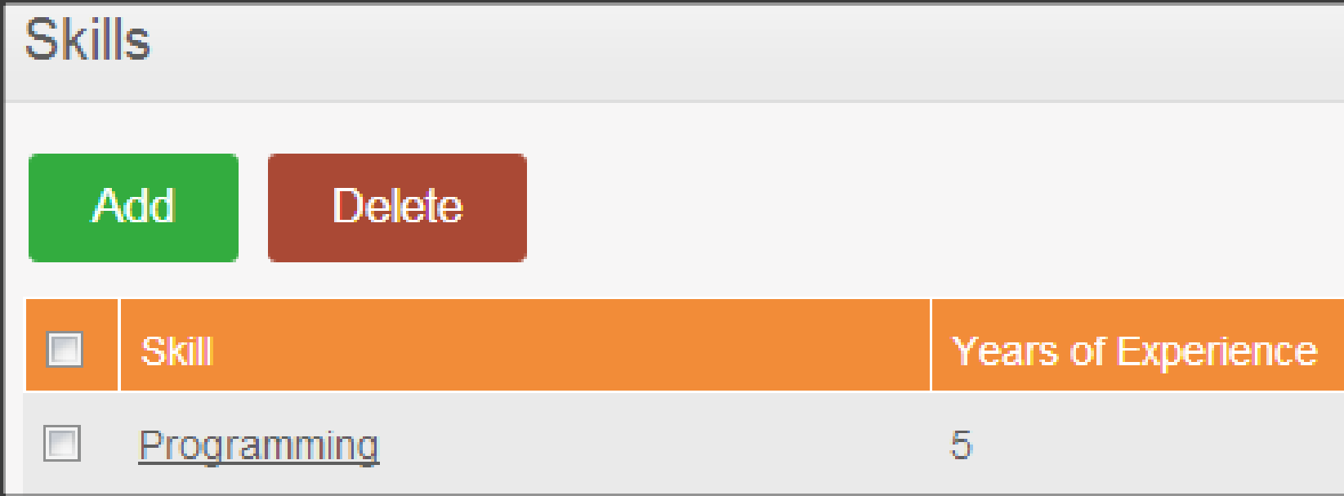

You may enter multiple entries of skills.

To delete an entry, click on the check box next to particular entry. It is also possible to delete multiple entries at the same time by clicking the check box entries you wish to delete and simply clicking “Delete”.

● Languages

You can enter the various languages that you are competent in, with the level of competency. To enter your language of competency, click “Add” under “Language” and the screen as shown in Figure 2.9 will appear.

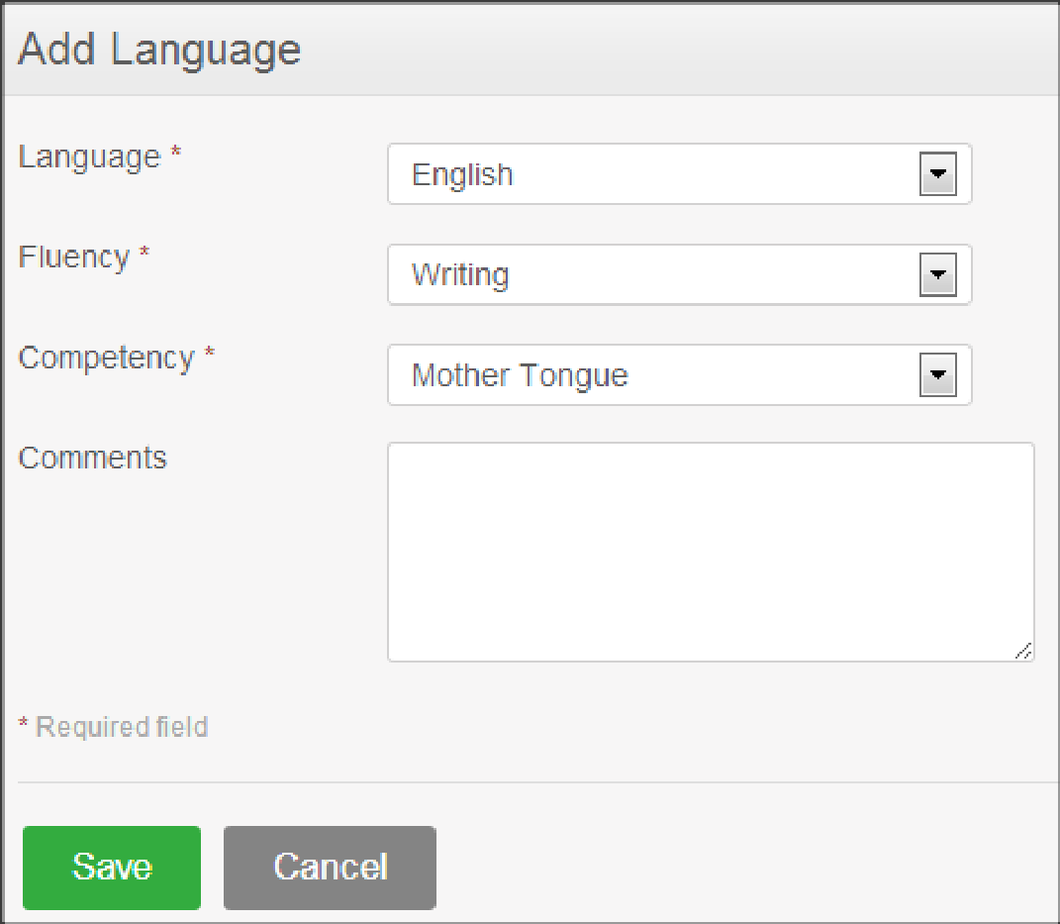

Click “Save” once all the fields are entered and the particular language of competency will be listed as shown in Figure 3.0. 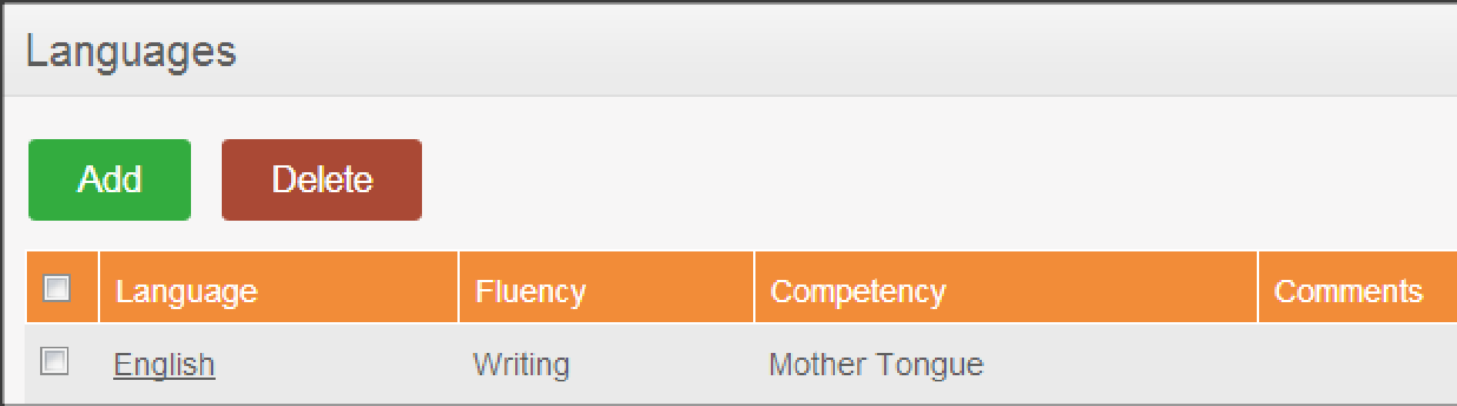

You may enter multiple entries of languages.

To delete an entry, click on the check box next to particular entry. It is also possible to delete multiple entries at the same time by clicking the check box entries you wish to delete and simply clicking “Delete”.

● License

Here you can enter the licenses that you may have. To enter licenses, click “Add” under “License” and the screen as shown in Figure 3.1 will appear.

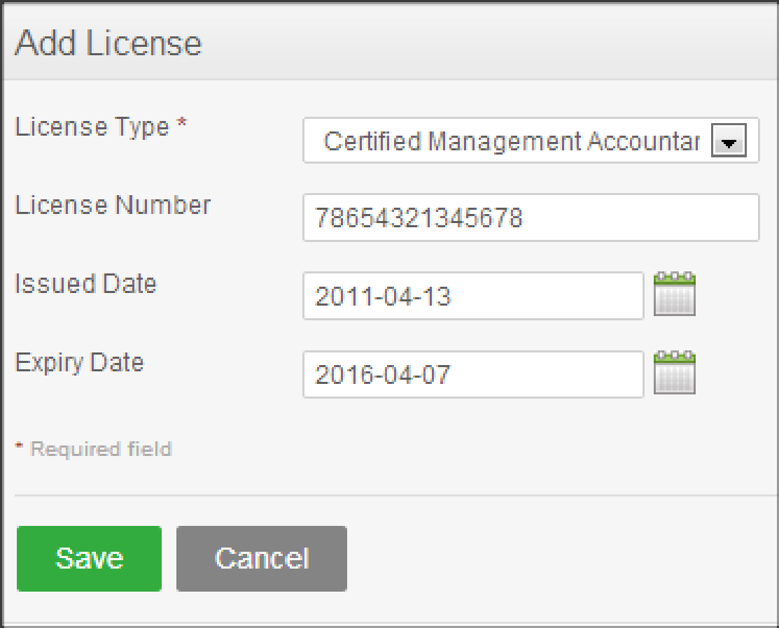

Click “Save” once all the fields are entered and the particular license will be listed as shown in Figure 3.2

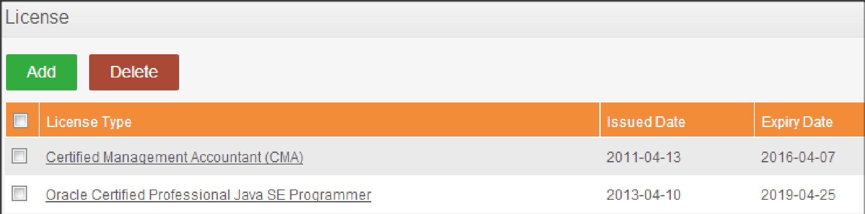

You may enter multiple entries of licenses.

To delete an entry, click on the check box next to particular entry. It is also possible to delete multiple entries at the same time by clicking the check box entries you wish to delete and simply clicking “Delete”.

**● Attachments**

Any supporting documents regarding your qualification that you think is needed by the management can be attached here. Please note that each document cannot exceed 1 megabyte, but you can attach more than one document. To add an attachment, click “Add” under attachment and the screen as shown in Figure 3.3 will appear.

Click “Browse” and select the file from the relevant path and click “Upload” to upload it.

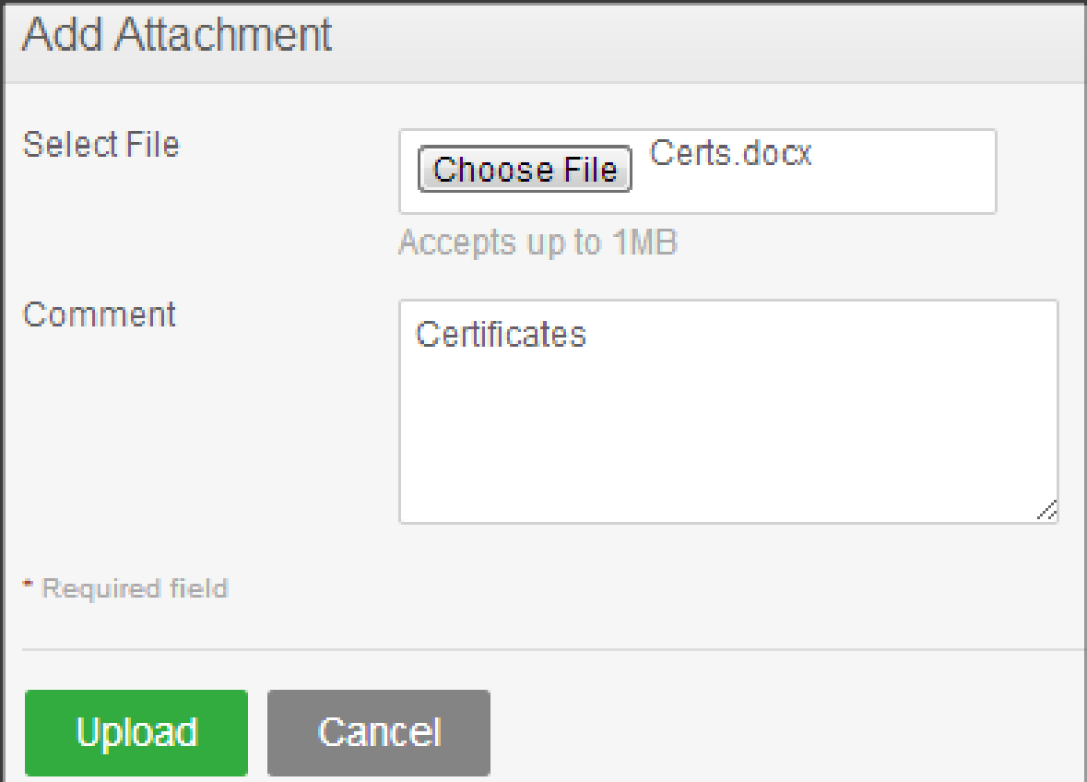

Once you have uploaded the file, the file will be listed as shown in Figure 3.4

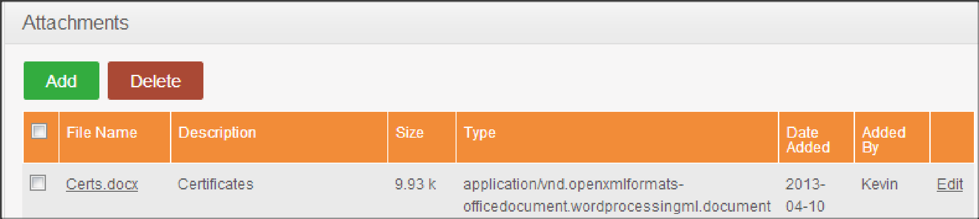

You may upload multiple attachments.

To delete an entry click on the check box next to the particular entry and click “Delete”. Multiple selections can be deleted simultaneously.

# Sign-Off Document

_____________________________________________________________________________

The following parties have read and agree with this Requirements Definition document for the OrangeHRM application account module functionality.

After approval of this Requirements Definition phase, any significant changes in the scope of this project will require validation of existing project costs and schedules.

______________________________________ _________________________________

Name Date

Business Lead

______________________________________ ________________________________

Name Date

Project Manager